PRACTICE 1 REPORT

«Simple semiconductor device circuits design and simulation»

**Principles of Circuits**

Student:

Program of Automation/ of Computer Science and Technology

ITMO ID: 375334

HDU ID: 22320404

Name Surname：Li Xin

Link to upload: <https://forms.yandex.com/cloud/650103e590fa7b299554a509/>

Work purpose: to study parameters of semiconductor elements and basis of the semiconductor device design

Goals:

1) Design rectifier model on the basis of diode «diode name»

2) Simulate rectifier scheme and analyze dependencies of DC voltage ripple from load and filter capacitor values variation

3) Simulate overvoltage and overcurrent states (optional)

# Starting data

### Parameters of the voltage source:

* One-phase sine voltage source
* Rectifier scheme: Central tap rectifier (CTR)
* Source voltage amplitude

$V_{s}$ = 95 (V)

* Source voltage frequency

f= 255 (Hz)

### Diode: (copy the 1stand the second line of .lib file of your variant)

### Required parameters of DC output:

* Load resistance:

RL = RLOAD_HWR/CTR/FBR =380 (V)

* DC link filter capacitor:

Creal =560uF

Practice REPORT №1

«Simple semiconductor device circuits design and simulation»

# Rectifier evaluation

## Diode simulation parameters evaluation

### Datasheet parameters:

|  |
| --- |
|  |
|  |
|  |

Fig.2.1 – Diode parameters for 25⁰C

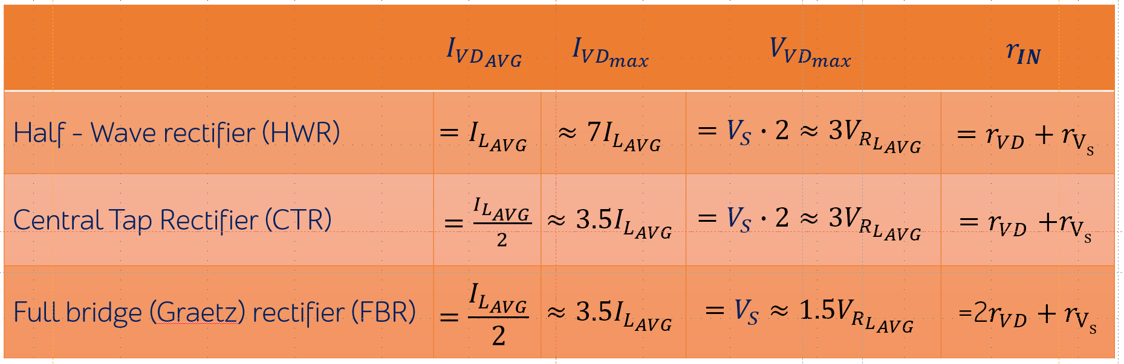

* Maximum average rectified current

$I_{VD_AVG}=0.2334$ (A)

* Maximum peak reverse voltage

$V_{VD_{max}}=190$ $(V)$

* Maximum peak surge current (as known as Maximum forward surge current or non-repetitive peak surge current)

$I_{FSM}=$ 30 (A)

* Maximum repetitive peak surge current

$I_{{VD}_{max}}=6.6365$ (A)

Diode forward bias voltage

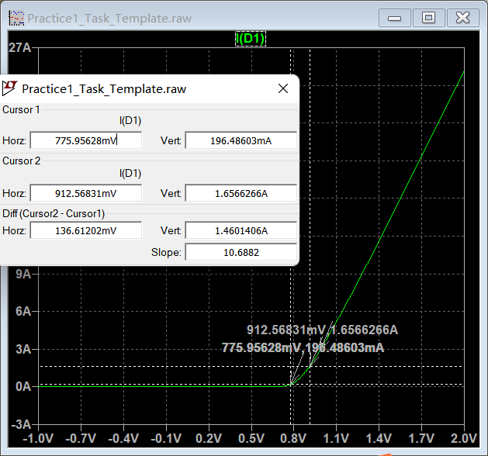

Fig.4.2 – Diode parameters for 25⁰C

$V_{fwd_max}\left(I_{{VD}_{max}}\right)=0.912568$ (V)

Diode threshold voltage:

$v_{ON}=$ 0.775956 (V)

### Diode active resistance:

$r_{VD}=\frac{V_{fwd_max}−v_{ON}}{I_{VD_{max} − I_{fwd}\left(v_{ON}\right)}}=$ 0.0936 (Ω)

## Diode rectifier with filter

### Source output resistance (overcurrent protection):

$r_{on}=r_{V_{S}}= \frac{V_{S}}{I_{FSM}}=$ 3.1667 (Ω)

### Input rectifier resistance:

$r_{IN}=\left\{\begin{aligned}r_{vd}+r_{V_{S}}, \text{for} \text{HWR}\text{ or }\text{CTR} \text{schemes} \\ 2∙r_{vd}+r_{V_{S}},\text{ for FBR} \text{schemes}\end{aligned}\right. =$ 3.2602 (Ω)

### Starting (Non-repetitive) maximum peak surge diode current in rectifier scheme

$I_{{VD}_{ON}}=\frac{V_{S}}{r_{IN}}=$ 29.1391 (A)

At this state, if $I_{VD_ON}>I_{FSM}$ it is necessary to increase $r_{Vs}= \frac{V_{S}}{I_{{VD}_{ON}}}$ and repeat evaluations 4.3.1-4.3.3.

### Diode opening state angle:

$θ= \left\{\begin{aligned}2∙\sqrt[3]{3∙π∙\frac{r_{IN}}{R_{L}}},\text{ for} \text{HWR} \text{schemes} \\ 2∙\sqrt[3]{\frac{3}{2}∙π∙\frac{r_{IN}}{R_{L}}},\text{ for }\text{FBR}\text{ or }\text{CTR}\text{ schemes}\end{aligned}\right.=$ 0.6864 (rad)

### Average load voltage

$V_{{R_{L}}_{AVG}}=V_{S}∙cos\left(\frac{θ}{2}\right)= 89.4593$ (V)

### Average load current:

$I_{L_{AVG}}=\frac{V_{{R_{L}}_{AVG}}}{R_{L}}=\left\{\begin{aligned}\frac{1}{π∙r_{IN}}(V_{S}∙sin\left(\frac{θ}{2}\right)−V_{{R_{L}}_{AVG}}∙\frac{θ}{2})\text{, for} \text{HWR} \text{schemes} \\ \frac{2}{π∙r_{IN}}{(V}_{S}∙sin\left(\frac{θ}{2}\right)−V_{{R_{L}}_{AVG}}∙\frac{θ}{2})\text{, for }\text{FBR}\text{ or }\text{CTR}\text{ schemes}\end{aligned}\right.=$

0.2354 (A)

### Average diode current:

$I_{VD}=\left\{\begin{aligned}\frac{V_{S}}{R_{L}}∙cos\left(\frac{θ}{2}\right)=\frac{V_{S}}{R_{L}}∙cos\left(\sqrt[3]{3∙π∙\frac{r_{IN}}{R_{L}}}\right)\text{, }\text{for} \text{HWR} \text{schemes} \\ \frac{V_{S}}{2∙R_{L}}∙cos\left(\frac{θ}{2}\right)=\frac{V_{S}}{{2∙R}_{L}}∙cos\left(\sqrt[3]{\frac{3}{2}∙π∙\frac{r_{IN}}{R_{L}}}\right), \text{for }\text{FBR}\text{ or }\text{CTR}\text{ schemes}\end{aligned}\right.$ = 0.1177 (A)

Compare with:

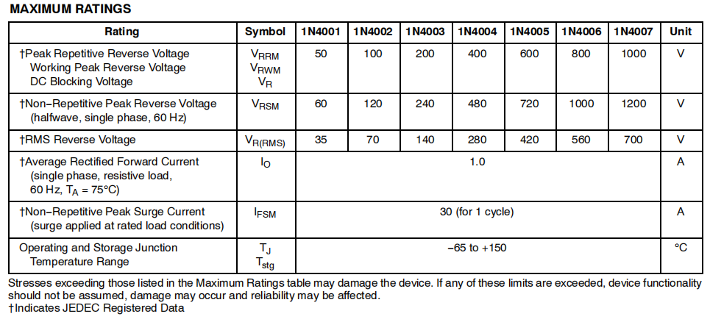

### Maximum repetitive rectifier scheme diode current:

$I_{{VD}_{max}}=\frac{V_{S}−V_{{R_{L}}_{AVG}}}{r_{IN}}=\left\{\begin{aligned}\frac{V_{S}\left(1−cos\left(\sqrt[3]{3∙π∙\frac{r_{vd}+r_{V_{S}}}{R_{L}}}\right)\right)}{r_{vd}+r_{V_{S}}}\text{, for} \text{HWR} \text{schemes} \\ \frac{V_{S}\left(1−cos\left(\sqrt[3]{\frac{3}{2}∙π∙\frac{r_{vd}+r_{V_{S}}}{R_{L}}}\right)\right)}{r_{vd}+r_{V_{S}}}\text{, for} \text{CTR} \text{schemes} \\ \frac{V_{S}(1−cos\left(\sqrt[3]{\frac{3}{2}∙π∙\frac{2∙r_{vd}+r_{V_{S}}}{R_{L}}}\right))}{2∙r_{vd}+r_{V_{S}}}, \text{for }\text{FBR}\text{ schemes}\end{aligned}\right.$ =1.6995 (A)

Compare with capacitor rated current.

### Peak repetitive reverse voltage:

$V_{{VD}_{max}}=\left\{\begin{aligned}V_{S}+V_{{R_{L}}_{AVG}}, \text{for} \text{HWR} \text{schemes} \text{or }\text{CTR}\text{ schemes} \\ \frac{V_{S}+V_{{R_{L}}_{AVG}}}{2},\text{ for }\text{FBR} \end{aligned}=\right.$ 184.4593 $(V)$

Compare with:



### Voltage ripple evaluated:

$ΔV_{R_{L}}=\left\{\begin{aligned}\frac{I_{L_{AVG}}}{2πf∙C}\left(2π−θ\right)\text{, }\text{for} \text{HWR} \text{schemes} \\ \frac{I_{L_{AVG}}}{2πf∙C}\left(π−θ\right)\text{, for }\text{FBR}\text{ or }\text{CTR}\text{ schemes}\end{aligned}\right.$ =0.6442 (V)

## Capacitor evaluation

### 

Fig.4.3 – Capacitor parameters

Pay attention to maximum tolerance rating: for the example in this case M= 20%

Tolerance

$M=20$ (%)

$C_{real}^{ }≥\frac{C}{\frac{100\%−M}{100\%}}=1,25C$ (F)

Choose new capacitor value if it is needed

$\frac{100\%−M}{100\%}C_{real}^{ }≥C=$ (F)

### After the nominal value is chosen:

$C_{real}^{ }$ =0.000560 (F)

$\frac{100\%−M}{100\%}C_{real}^{ }$ =0.000448 (F)

$\frac{100\%+M}{100\%}C_{real}^{ }$ =0.000672 (F)

## Expected parameters of the developed rectifier

### Voltage ripple:

$ΔV_{{R_{L}}_{}}=\left\{\begin{aligned}\frac{I_{L_{AVG}}}{2πf∙\frac{100\%−M}{100\%}C_{real}^{ }}\left(2π−θ\right) , \text{for} \text{HWR} \text{schemes} \\ \frac{I_{L_{AVG}}}{2πf∙{\frac{100\%−M}{100\%}C}_{real}^{ }}\left(π−θ\right), for FBR or CTR schemes\end{aligned}\right.=$ 0.8052(V)

$ΔV_{{R_{L}}_{}}=\left\{\begin{aligned}\frac{I_{L_{AVG}}}{2πf∙C_{real}^{ }}\left(2π−θ\right) , \text{for} \text{HWR} \text{schemes} \\ \frac{I_{L_{AVG}}}{2πf∙C_{real}^{ }}\left(π−θ\right), for FBR or CTR schemes\end{aligned}\right.=$ 0.6442(V)

$ΔV_{{R_{L}}_{}}=\left\{\begin{aligned}\frac{I_{L_{AVG}}}{2πf∙\frac{100\%+M}{100\%}C_{real}^{ }}\left(2π−θ\right) , \text{for} \text{HWR} \text{schemes} \\ \frac{I_{L_{AVG}}}{2πf∙{\frac{100\%+M}{100\%}C}_{real}^{ }}\left(π−θ\right), for FBR or CTR schemes\end{aligned}\right.=$ 0.5368(V)

# Conclusions

# Conclusion should contain:

# 1) Diode check results:

# •Is breakdown voltage check passed? Is voltage source changed because of overvoltage?

The breakdown voltage check passed, as the maximum peak reverse voltage was within the diode’s rated limits

# •Is starting current check passed? /Is additional resistance r_vs added to prevent overcurrent in diode/capacitor?

Passed.The initial peak current reached 29.30 A, and an additional resistance rvs=3.1667 Ω was added to prevent excessive current in the diode and capacitor.

1. **Capacitor information: nominal value, tolerance, allowed current**

· Nominal Value: 560 µF

· Tolerance: ±20%

· allowed current:1.67A

**3) Ripple factor value**

0.0037

# Appendix А.

### MUR550APFG

|  |
| --- |
|  |
|  |
|  |
|  |

Fig.1. Diode parameters for 25⁰C

# Appendix В. VariantNo04.lib listing